BATTLECRY: the plan to change publishing for the better
  - Audience Development and Marketing Plan
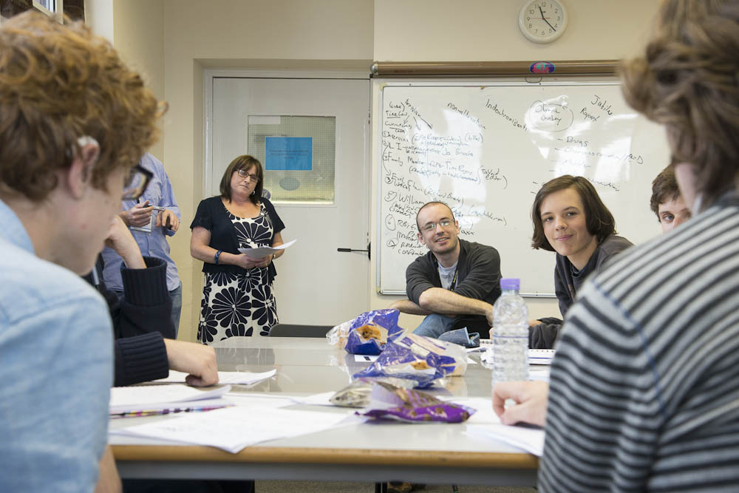
This is the audience development plan for eQuality Time’s ‘BATTLECRY’, running in June 2018.
Table of Contents
Concept 2
Background information: eQuality Time. 2
The Event 2
Identifying Our Audience 2
Writers 3
People following the process 4
Online 4
Press engagement 4
Evaluation of audience development objectives 4
Describe how you know that there is demand for your activity from your target audience, and provide details of any research you have carried out. 5
Audience development and marketing methods 5
Timetable & Budget 6

Concept
During a time when publishing is seen as slow, unrepresentative, and in danger of collapse, 20 of the best young British writers will team up create two topical novels that are relevant to the changes in life in 2018/2019. They will go from blank pages on Monday morning to a publication on Sunday night.
eQuality Time will select these writers for their words and their ability to speak to audiences whose voices aren't heard in mainstream publishing. Audiences will be hit by the twin shock of characters that are both like them and are reacting to events that they themselves are still processing.

Background information: eQuality Time
eQuality Time designs artistic interventions for social problems and has a strong track record working with groups of writers and media-focused young people to produce large-scale cultural artefacts.

In our work it has become clearer and clearer to us that traditional publishing mechanisms have significant issues in terms of diversity. The 2015 report: ‘Writing the Future: Black and Asian Writers and Publishers in the UK Market Place’ found that BAME authors were less likely to be published or have an agent and were pushed to have their characters match cultural stereotypes. The 2015 Diversity Baseline Survey Results found massive underrepresentation for disability at all levels in the publishing industry, At the same time, writers are more likely to been privately educated and older.

At eQuality Time we have a mission to level the playing field in all areas, we’ve started by expanding the aspirations and skills of disadvantaged children, and now that are process has been proved, we have a moral obligation to take the same approach at a higher level, and work with those artists on the cusp of greatness. Making publishing more inclusive is something we need to do and we have designed a project that can do it.

Audience Objectives
In the previous sections, we illustrated the problems that we want to solve, in this section we list those indicators that will let us know that we have made progress in solving it.

To increase diversity and ‘cultural reactivity’ we wish to demonstrate to writers, readers, and significantly, the publishing industry that:

- Increasing the diversity of authors increases the quality of content produced and the size of the market for long-form fiction.

- Collaboration between groups of talented writers produces higher quality output, and that this output can address cultural changes much faster than other approaches, and again this can grow the size of the market for long-form fiction.

To do this, our activity is in two parts:
- the creation of two ‘specimen novels’– by allowing diverse artists to give their voices in tight collaboration we create an artifact that can show this new approach to long-form fiction
- disseminating the work that we have created to readers, and people in the publishing industry as an illustration of the power of the approach and the motivation for change.
Our ‘SMART’ goals are:

- At least five articles about the process in significant (list below) publications for writers before writing starts.
- To demonstrate, both in general and in the specific case of our novel, that more diverse writers, and faster ‘to-bookshop’ times would increase new book buying among members of the public that buy less than five books in a year. We will demonstrate this by focus group and survey within two weeks of the novel publication and send out relevant press releases within three weeks.
- At least three articles in national newspapers about the process following the production of the novel within a month of publication.
- At least one review of the content itself in a national newspaper within a month of publication.
- Five dissemination talks given at publishing industry events within six months of the project end.

The details of your activity
To active the above objective, we developed the following project.

Audience: 20 underrepresented British writers
This is project compensates two groups of professional- standard writers for the time over week-long periods to produce two full length literary works on topics in the 'now'. For each novel, ten of the best young British writers from underrepresented groups will team up create a topical novel that is relevant to the changes in life in 2018/2019. They will go from blank pages on Monday morning to a publication on Sunday night and show that the long-form novel remains a reflection of life rather than a memory of it.

Benefits to Audience
Writers accepted onto the project will be paid – a fundamental part of our approach and this project is that we belief that writers and artists should be fairly paid for their work. More importantly, these writers will be given the chance to have their voices, and those of their communities heard in a landscape that is far from inclusive. The writers will have the opportunity to learn from each other, be part of a demanding but thrilling new process and grow as a result of it.

Demand for activity
It is an accepted truth in the world of publishing that there are far more people sending in manuscripts than there is time to read them. The thousands of ambitious individuals who want to publish their own novel is enough to keep afloat a sizable cottage industry of ‘writing retreats’, courses, ‘how to get published’ books, websites and magazines.

Audience development and marketing methods
Our writers will be taken on their own journey.

There are several organisations that specialise in fiction produced by writers from diverse backgrounds. We have had firm commitments from the following organisations to help us recruit participants for the project:

- Inclusive Minds
- Spread The Word
- Common Word
- Letterbox Library
- The Writes of Woman

In addition, communities of potential participants will be reached by a
a program of carefully targeted advertisements in more mainstream outlets. Our initial list of organisations is:

- Poets & Writers Magazine
- Room
- Writers Online
- Writing Magazine
- Writers Forum
- Writers News (who have already featured the project twice)
- The London magazine
- Granta
- Mslexia
- London Journal of Fiction

To particularly focus on young unpublished writers, we’ll also be producing content for the following online communities of writers:

- Absolute Write Water Cooler
- Writers Network
- The Next Big Writer
- Inked-In
- Reddit Writing Subreddit
- Gather
- Agentquery Connect
- Bookrix
- Critique Circle
- Trigger Street Labs
- Critters Writers Workshop
- Suite101
- Figment
- Hatrack River Writers Workshop
- Writertopia
- MIBBA
- NANOWRIMO

From here interested writers will be invited to apply by sending short fiction pieces as CVs. Writers will be shortlisted by a panel consisting of Dr Reddington, Dr Cowie, and Ms Baker (Cowie and Baker in their capacity as professional writers), and 38 will be invited to a selection day designed to both only identify the best team of writers for the full novel and also develop the talents of all of the shortlisted writers.
We will select these writers for their words and for their ability to speak to audiences that feel their voices aren't heard in mainstream publishing. Audiences will be hit by the twin shock of characters that both like them and are reacting to events that they themselves are still processing.

Audience: readers of contemporary fiction who buy fewer than five books a year
From a 2014 YouGov survey, 39% of the publish public buy fewer than five books in a year, but the vast majority of them do buy some. (Source, YouGov). These are people who do read, but rarely. Finding ways to increase book sales in these groups would significantly grow the market.

Benefits to Audience
We will deliver to this audience a novel that more accurately voices the diversity of the modern UK and also reflects recent events. Audiences will be hit by the twin shock of characters that both like them and are reacting to events that they themselves are still processing.

Audience development and marketing methods
Because the writers are completing the novel in such a short space of time, we can take serious advantage of that in our audience development.
The week before our writers start work, we’ll be running focus groups with representative samples of UK readers who buy less than five books in a year. This is our chance to find out:
- How these readers like to be challenged
- The recent world events that they are talking and thinking about
- The ‘missing stories’ that these readers want to see more of.

Focus groups only give direction on the ‘setting’ – things like location, time period, events to include (at the time of writing, this might include the collapse of Carillion), and a small set of comments about potential viewpoints to include. All narrative-related information is stripped out before the information reaches the writers who will build stories that appeal to the target audiences around events and places that are cultural touchstones.
During the week that the novel is being written, our staff will be testing potential names for the work, along with the design of covers and other marketing materials.
The week after publication of our novel, we’ll be running further focus groups with readers to see if we have successfully shown readers that there is a potential new world of books that can address their needs much better than the current publishing industry.
We’ll be co-ordinating our press strategy with the aid of Consilium Communications.
We believe that the unique nature of the project we ensure wide publicity, and that our ability to comprehensively tailor it to the audience will generate a high number of satisfied readers and word of mouth. This will help the book find it’s way to target readers both during the project and beyond it.

Audience: professionals in the UK publishing industry.
The invoiced value of UK book publisher sales at home and abroad across physical and digital formats was £3.3bn in 2014, with 17 per cent of this figure accounted for by digital sales. (1)
Exports of physical and digital books were worth £1.45bn to UK publishers in 2014. (1) http://www.thecreativeindustries.co.uk/industries/publishing/publishing-facts-and-figures

The Creative Industries Economic Estimates are the official statistics used to measure the economic contribution of the creative industries in the UK and quote 255,000 people employed in ‘publishing’. Even if we assume only 5% of that number is in fiction publishing, that is a large audience of individuals to reach.

Benefits to Audience
Publishers are keen to find ways of increasing the quality of their output, increasing the size of their market, and reducing their costs. We can demonstrate to them effective ways of doing all three of those.
To increase diversity and ‘cultural reactivity’ we wish to demonstrate the publishing industry that:

- Increasing the diversity of authors increases the quality of content produced and the size of the market for long-form fiction.

- Collaboration between groups of talented writers produces higher quality output, and that this output can address cultural changes much faster than other approaches, and again this can grow the size of the market for long-form fiction.

- Collaboration between groups of talented writers over very short periods of time reduces the costs to authors of producing books (ten produce more in a week than one does in ten weeks) and this cost saving can directly be passed to the publisher.

Audience development and marketing methods
Potential influencers in the area will be reached by a program of carefully targeted advertisements, talks, and outreach to create a ‘buzz’ around the project. Our initial list is:
- Publishers Weekly
- The Bookseller
- Professional Publishers Association
- British Printing Industries Federation
- Society for Editors and Proofreaders
- Writers' Guild of Great Britain
- Independent Publishers Guild
- Association of Authors' Agents

