Supertitle Phase 2 report
  - Lessons learned and goals achieved

Summary

This report talks about the performance of the Supertitle project in several different areas.

We’ve run sessions in 10 schools so far, working with around 60 students in six languages. We’ve made our materials and our technology better and we have a more effective approach to teachers.

There are some problems with our approach. This report talks about changes that we can make to remove those problems. The key changes are:
- Name two or three languages and only work with those.
- Send teachers the student forms before the sessions start.
- Work with schools where there are more than, say, 25 students who could join the group for a language.
- Expand to work with community organisations as well as schools.

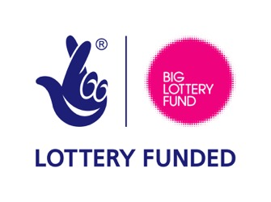
##############
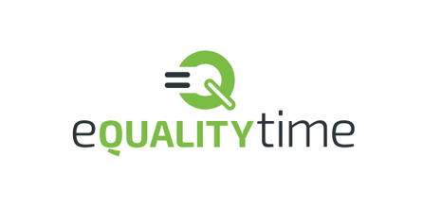
There have also been failures around our ability to build critical mass in any one language and to build ‘strength in depth’ in those schools we’ve worked with. This report discusses those failures in detail and makes
a range of recommendations to move us forward.

Table of Contents
Summary 1
Introduction to interim report 2
Successful changes 2
Enguagement with producers has been excellent 3
In school experience 3
Research 3
Areas for Improvement around recruitment 4
Moving away from schools 5
Finance 5
Changes to be made 6

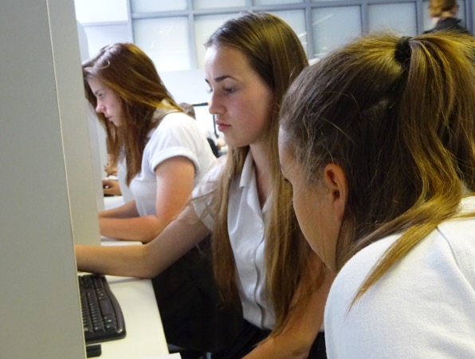

Joe’s Introduction to interim report
The funder for this part of the Supertitle project is Awards for All. They would like a report by the end of September, and I believe it is a good idea to start it now. Right now we can think carefully about where we are and check that everything in the plan has been done.

Technology and process
The subtitle fetching and subtitle displaying tools that created for Supertitle have worked well, but there are areas we can do better in:

*The subtitles look 'cheap' when shown
*The subtitles require several megabytes of bandwidth. This is low in normal life, but schools have very low levels of 3G and 4G signal. This had made showing the finnished work harder at the end of a session.
*Placing the files for a programme online is done by Joe, and this both takes time, and lowers teacher flexibility.

We have already taken steps to change the tools. We employed a freelancer who has created new display tool, which is attractive and low-bandwidth. It is in the process of been made to work with other tools. In the future, we will look carefully at ways to give teachers the chance to place their own files online.

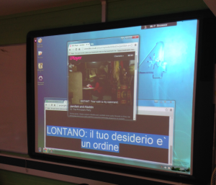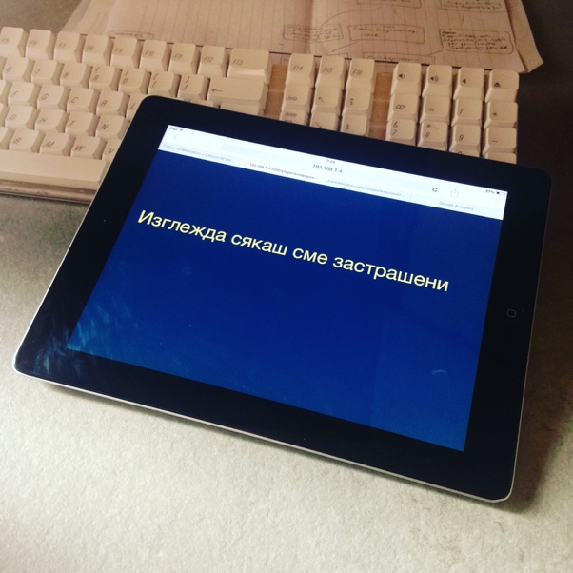

In the room
An interesting aspect that needs to be fixed is that the translation pages need more information. For languages like Spanish and Portuguese it should be clear to the students which version they are using, and the percentage complete should be automatically included. Moreover, it is clear that the proofreading stage is very very weak - translations tend to be ‘done and go’, which is some distance from the effective program that we imagined.

In person, we can also show much higher quality subtitles by directly replacing the BBC’s own subtitle files on the local iPlayer. It’s very useful for events like doing a showing for parents at the school.

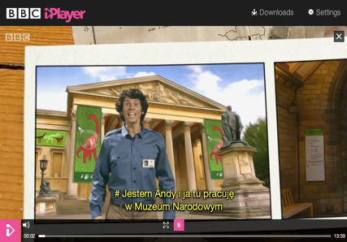

Engagement with producers has been excellent
We have been helped by the TV show makers themselves.

“Hi Dino adventurer’s – Andy here from Andy’s Dinosaur Adventures. I’ve heard all about the hard work you’ve been doing translating my latest adventures so that your friends and families can enjoy the show. I only wish I could speak every language so they could enjoy them first hand, but your translations are fantastic!”
Exciting news hot off the press – we’re making another 25 episodes – this time set in prehistoric times - watch out for those next year! As well as featuring more dinosaurs, the clock will take me back in time to the Ice age where I’ll get to meet Woolly mammoths, Sabre toothed tigers and even some cavemen – it’ll be great. And unless I learn some other languages quickly, I’m going to rely on you to translate those also so everyone can enjoy them.
Keep up the great work
All the best, Andy”
Andy Day, Andy's Dinosaur Adventures
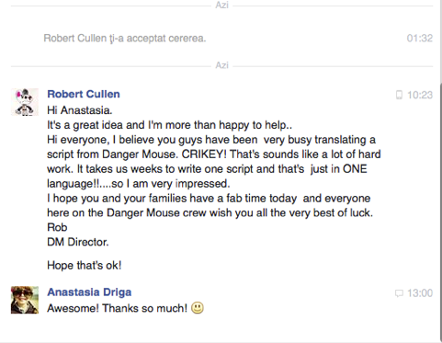

Dear Joe,
This sounds like a fabulous project. The Leopard Drama team feel very honoured that you’re going to watch Eve together.
Well done for all your hard work on this project.
Wishing you all great success and a fun robotic time,
Jez Swimer
Series Producer, Eve

Recruiting Schools
It took less effort than expected to find 10 schools to work in. We only contacted around 80-100 schools by email and the response rate was very strong. We needed to do almost no following up. There is a very clear need, and schools are very happy to be seen to be working on it. Only schools in a small local area (two areas, because Joe moved) where contacted, and we would expect that we could get the same rate of response across London.

We can make several things better:
- press - we should be appearing in the local paper, and giving schools press releases.
- working with local communities - allowing parents and students to suggest the idea to schools.

I removed two schools from the project. One was because the school blocked Google Drive and the other was because the students started to write nasty messages to each other using the software. In the second school the poor behaviour of the children at the school was evident from the first visit, with teachers having no control over students.

Research

One of our big problems has been in research. We first tried getting the students to fill out questions online at the start of the first meeting. However took up a lot of the time in the first meeting and removed a lot of the 'fun'. Students with a low level of English were most affected, which is completely the wrong outcome.

Early on we switched to paper forms, but the completion rate has been poor. Even had the research logistics been successful, the UK’s Brexit vote happened between baseline and the final assessment, rendering any change in ‘belongingness’ to be subject to factors outside our control!

We can make several things better:
- Create the set of questions in our target languages
- Give teachers the question set before the meeting, and ask the students to bring a completed copy to the session.
- Consider a control group of students outside of the project.

Areas for Improvement around recruitment
Our largest failure was that the set of TV shows that we worked on failed to reach ‘critical mass’. The completed shows came from a wide range of languages and there was little reason for someone to come back to see something else. The set of TV shows was NOT a useful resource for any of the language communities.

This had knock-on effects regarding income. We had grand plans for selling advertising on the subtitles later on. With a useful resource for any single language we have little to offer to advertisers.

I believe that part of this problem was that the students we worked with were NOT the best choice in any given school, and that was caused by the teacher's incentives.

Speaking to several of the teachers we worked with, it became clear that none (in the small, nonrandom sample) of the groups we had set up, were for the biggest additional language of the school. We had a Spannish group in a school where around a third of the students spoke Arabic, Romanian in a school that had a large number of Turkish students and Italian in a school that had many more Polish students.

In the teacher's view, they stated that they wanted to work with those groups that they saw as having the most difficulties. We might also note that five of our ten schools targeted Spanish speakers, and all of those groups had one or more spanish speaking teacher in attendance. It is possible that teachers wanted to be able to 'check' the work that was coming out.

While the teacher's position is understood (It is only in writing this report that some of the effects of this have become clear), the smaller groups were very vulnerable to folding if a couple of students dropped out, provided less of an audience for the created subtitles, and found it very difficult to grow. Smaller groups also were less productive and had to work on less 'cool' TV shows because they were shorter.

By comparison, in our pilot study with Polish students, the group grew from three students to 12 for the final (10th) week, and cumulated in a community event. However, when there are only four students in total, this means that only one has to drop out before the process becomes unsustainable. In such cases, it is hard to reach a ten week, or often even five week project.

Our initial target was that we were interested in working with the ‘majority minority’ languages like Polish, Urdu and Bengali. These were groups that had large presence in schools, with a variety of language levels and with established communities outside of it. None of these languages were requested by the schools we worked with.

We can make several things better:
- Name two or three languages and only work with those.
Focusing on fewer languages makes it easier to create a resource for the community, easier to have schools check each other's work, and easier to make inroads into a community. Being clear with teachers that we are only prepared to work with particular students gives us a stronger brand. Once there is a usable resource we can also advertise those results (it is relatively easy to target speakers of particular languages in, say, London using Facebook ads.
- Work with schools where there are more than, say, 25 students who could join the group for a language.
If a Supertitle club has a 'deep bench' then it is far more likely to last longer, and become better at creating content. There is also a bigger local audience.
*Expand to work with community organisations as well as schools.
It is entirely possible then that the correct route into the work is NOT the schools, but is the community centers for certain languages.

One thing that may need compromise. It's my opinion that Supertitle is more effective if there is NO adult target language speaker in the room. On the other hand, teachers appear to be much happier when they can check things over. It is possible that if we are choosing only one language, that we can employ someone who has that language to visit the schools and run the early sessions. This would reassure the teachers and give us a someone with local community knowledge.

Moving away from schools

Finance
Our budget has been relatively sensible. Our accountants fees was split between legal advice and accounting, which is quite reasonable, but I suspect that our budget for equipment was too high compared to that of facilitation. We are generally underspent.

Comments from Students

Students at La Retraite have learnt how to translate subtitles in Spanish
and Portuguese for famous BBC programmes using Supertitles. Dr Joe
Reddington came to deliver two sessions of 2 hours to about 15 girls. The
girls enjoyed this very much because they were able to use their languages
to produce something useful. In addition they were able to work as a team
(one Spanish and one Portuguese).

These are some of the comments from the students:

“I found this workshop fun and useful because you are helping people that
don’t understand it and need translating it. I am really happy that I was
able to take part in this session and I was able to use my skills to work
as a team”

Jessica Almeida

*“*I found the workshop very useful because I worked well in a team and
it helped me writing with more confidence in Portuguese. Also, I have made
new friends. I have had really good fun”

Nicole Figueira

“I found this session very useful because I practised my Portuguese and I
also know that by producing the subtitles I can help Portuguese people in
the UK to understand what they are watching. I found it really fun as well
as useful”

Tecia Neves.

“I enjoyed this workshop as my family also face the struggle of not always
understanding shows and I am glad to give back to the community by helping
others who have the same problem.”

Mariana Dias

I liked the work shop so much! It helped me improve my language skills. It
was really helpful and I would love to participate in future workshops.

Maria-Jose Ramos Cuadrado

Students are now looking forward to meet once

