Supertitle: Phase two
This is a ‘pretty printing’ of eQuality time’s bid for Virgin’s #iwillTakeAction fund. It also serves as a snapshot of eQuality Time’s position and intention towards the Supertitle Project. It is a living document in its own right and contains a large amount of information and illustration that is intended for sharing with the wider public rather than a funding body.
This document opens with a summary. Questions from the Virgin Application form are highlighted in red.

Supertitle
Supertitle is a school intervention for students with English as an Additional Language (EAL). Students with EAL produce gain confidence, volunteering experience and teamwork skills while producing subtitled versions of UK TV programs by forming ‘translation clubs’ that use specially designed software. This help members of the wider community improve their English and improves the accessibility of UK media and cultural outputs.

Futher reading.
Supertitle is one of eQuality Time’s first projects and we have blogged every stage of it’s development:
2016

- Supertitle Phase 2: report
- Sir Halley Stewart Trust Bid
- Children in Need Funding.
- New shows for Supertitle
- New Shows prepared for Supertitle
- Children in Need interview
- Children in Need Application
- New shows prepared for Supertitle
- The 60 second silent Supertitle video
2015
- Project Update: Supertitle
- London Catalyst
- Funding Success – Awards for all and Supertitle!
- Fail post: Supertitle Funding
- Prototyping Supertitle
- Supertitle, a project for school students with English as an additional language.

Bid

Tell us about your organisation. What does it do? Why was it set up? Who set it up? – 500 words

eQuality Time designs and delivers social interventions, where our end-users work as a group to deliver an end product like a novel or community resource. While focused on their end-goal, our users find themselves improving their skills, and forming effective team bonds. eQuality Time was set up by Dr Joe Reddington in 2014, to address gaps in the education and volunteering sectors.

Two of our projects are:
The Supertitle project aims to increase EAL students’ confidence, locus of control and self-esteem. In Supertitle clubs, students work as a team to translate subtitles. As a consequence, their English language skills are developed in a way that is led by peers, avoiding the stigma normally associated with remedial lessons. Volunteering their time to work localise UK media outputs, in support of their community enables them to act as a bridge between two cultures.

In 2015 it was awarded National Lottery funding to help with the initial pilot project costs. Under the project, students form volunteer groups to translate subtitles We’ve run sessions in 10 schools so far, working with around 60 students in six languages.

The White Water Writers project enables groups of up to ten writers to write and publish their own novel within five days. Writers are given an idea for a story on a single side of A4. They take the idea, develop it, draft it, proof it, refine it and polish it. After four and a half days – they publish it, making it available world-wide on Amazon. Our in-school week-long writing ‘sprints’ are facilitated by volunteer students from local universities, who are fully trained and DBS-checked. The project develops writing and communication skills, teamwork and attention to detail whilst raising attainment and achievement as well as aspirations and self-esteem.

White Water Writers was initially grant funded from several sources but is now commercially viable. The novel writing process is entirely student led - no adult touches a computer key throughout. Over 70 novels have been produced to date and our research with Keele University and Kings College London, shows statistically significant increases in student confidence and locus of control. Students have also demonstrated improvements in their planning skills, use of computers and team work.

Tell us about your project. How will your idea help young people living in the North East to engage in social action? This question will be assessed by our youth advisory panel. – 500 words

In many schools, adolescents from migrant backgrounds are routinely placed in classes for low ability pupils because bilingualism is still wrongly associated with special education needs. These children do not get the quality education they deserve, which affects their self-esteem and confidence (http://www.ioe.ac.uk/56528.html) English as an additional language (EAL) students can struggle to engage with cultural norms such as sport, television and media. EAL students feel torn between two cultures at a time of their life when all children are forming their identity, which results at best, in poor education outcomes and at worst, risk of radicalisation.

In the wider community,
UK Television programs provide subtitling in English. However, almost 1 in ten UK households have a member that doesn’t have English language, (http://www.theguardian.com/uk/blog/2012/dec/11/census-data-released-live-coverage). In such households UK media is generally not watched in order to avoid (further) isolating members of the household. This has a range of knock-on effects.
By solving the second problem, we believe we can help solve the first.
Supertitle clubs create subtitle translations to popular BBC and ITV tv programmes in the common UK additional languages of Polish, Punjabi and Urdu. A school-based Supertitle club is made up of

volunteer EAL students who meet once a week to translate subtitles for an episode of a popular British TV program. Our software allows groups of EAL students to work together on the translation and to make it available online as a community resource allowing volunteers to feel like a bridge between communities rather than feeling they have to choose a 'side'. The community benefit will be demonstrated as translated subtitles help non-English speakers of households improve their English and thus help integrate them better into society.

A major reason why young people do not engage in social action is they do not believe they have anything useful to contribute. In particular, EAL students often feel their native language to be of little or no value both in school and peer groups (http://www.ioe.ac.uk/56528.html). However this project puts those language skills at the absolute centre – and causing young people who do not normally volunteer to do so.

This project is to set up Supertitle clubs in
50 schools in the North East to improve English as an Additional Language (EAL) students’ confidence, locus of control and self-esteem.

Our intended outcomes for implementing Supertitle in 50 schools for an estimated 600 EAL students are:

*It will enable more students to benefit from the programme, increasing their confidence, locus of control and self-esteem.
* 50 teachers will have been trained as Supertitle facilitators and will have established Supertitle clubs.
* Between them, the network of clubs will produce target language subtitles for all prime time BBC programmes, creating resources that can be used by all target languages in the UK.
*Expanding Supertitle to a wider group will enable eQuality time to collect representative impact data that demonstrates the effectiveness of the programme. This can be used to advocate to local authorities for its incorporation within urban schools throughout the UK.

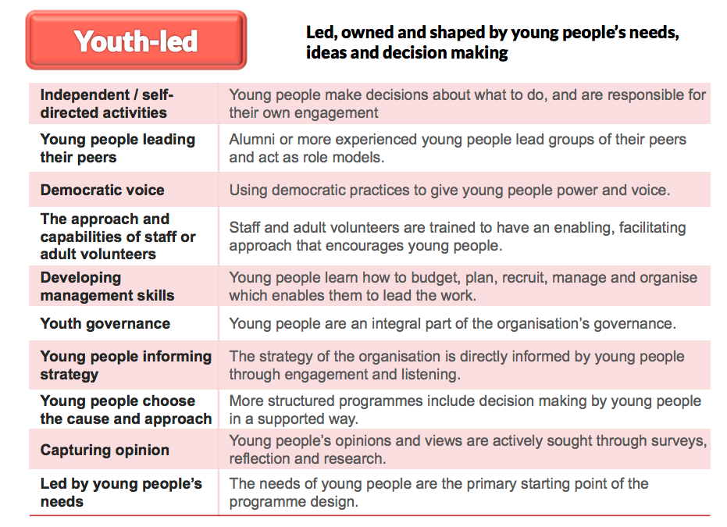

How will you involve young people in the planning and delivery of your project? This question will be assessed by our youth advisory panel. – 500 words (see above)

The primary starting point for our our project Theory of Change for this project is the needs of the young people with English as an Additional Language and
our staff are recruited specifically for an enabling, facilitating approach that encourages young people. Group decisions are made democratically and consistently by the young people, whose opinions and views are actively south through surveys, focus groups, interviews and research. Much of the group discussion naturally takes place in the home language of the group and because we make sure that no adult present is familiar with that language, the young people are aware of, and empowered by, the trust placed in the group.

# Planning
The Supertitle pilot interventions were carried out with four groups of students, all of whom were canvassed for their opinions on the approach. The students specified changes to software (which changed dramatically as a result), delivery type (we created more options for how the intervention could be run), and the delivery of the finished programs (we originally envisaged small groups watching at home- the students we worked with set up larger scale viewings in school halls with presentations).

# Delivery
Each Supertitle club is volunteer led. Volunteers democratically select which TV programmes to translate, the roles that each member of the team will take, and are responsible for making the final decision about when a translation is ready to be put online. Clubs are youth-led to keep the focus on young people and draw upon their creativity, energy and skills to create a positive change in their own communities. This also helps to ensure their commitment to the club as well as to enhance their self-belief, that they can achieve anything they put their mind to.

During the translation process, there is an adult facilitator present for help with the technology aspect but all decisions regarding translation will be made by the volunteers. The only people in the room with knowledge of the target language are the student volunteers, this will help ensure that no other adults will have had an input and the final work is ‘owned’ by the volunteers.

When children choose to write subtitles for UK TV programmes, they are identifying a cultural product that resonates with them. Group discussions of how best to translate a particular phrase explore cultural differences and similarities in a safe, meaningful way.

What evidence do you have to show that your idea will work? How will you measure outcomes? What will happen at the end of the grant? – 500 words

The funding we have received to date has allowed us to pilot Supertitle in 10 schools. 30 sets of subtitles have been produced by groups in Polish, Italian, Lithuanian, Spanish and Portuguese. Testimonials from students support the project theory of change and include:

“I found this session very useful because I practised my Portuguese and I
also know that by producing the subtitles I can help Portuguese people in
the UK to understand what they are watching. I found it really fun as well
as useful”

“I enjoyed this workshop as my family also face the struggle of not always
understanding shows and I am glad to give back to the community by helping
others who have the same problem.”

“I found this workshop fun and useful because you are helping people that
don’t understand it and need translating it. I am really happy that I was
able to take part in this session and I was able to use my skills to work
as a team”

Our intended outcomes and their measurement strategies for implementing Supertitle in 50 schools for an estimated 600 EAL students are:

*It will enable more students to benefit from the programme, increasing their confidence, locus of control and self-esteem. This will be measured by giving each student a pre-post assessment designed by researchers at Keele University in conjunction with eQualityTime
* 50 teachers will have been trained as Supertitle facilitators and will have established Supertitle clubs. This can be measured using our software.
* Between them, the network of clubs will produce target language subtitles for all prime time BBC programmes, creating resources that can be used by all target languages in the UK. This information will be publically available and we will produce a condensed report.
*Expanding Supertitle to a wider group will enable eQuality time to collect representative impact data that demonstrates the effectiveness of the programme. This can be used to advocate to local authorities for its incorporation within urban schools throughout the UK. This can be measured using website

to keep track of download numbers of the translated subtitles as well as an optional online survey made available when choosing to download the subtitles.

Supertitle's long-term plan will see the development of a sustainable set of youth-led clubs which will be measured by tool usage as well as recording the figures on club membership.

The data will then be used to write a report to discuss the performance of Supertitle and how the clubs can be improved.

When this grant finishes, Supertitle will have created a small set of youth-led translation clubs in schools across the North East that are providing transtions to the majority of primetime terrestrial programs. . This grant will allow us to amass a critical body of content and evidence, which we can use to convince schools and colleges to take on the intervention and support facilitator costs, making the project financially independent. The next step will be to scale the intervention nationally.

How will you use the strength of the Virgin Money brand and the skills of staff from across the business to magnify the impact of your work. How will you help Virgin Money Foundation to raise awareness of the #iwill campaign? - 500 words
The Virgin Money brand will be of enormous help when convincing other schools to introduce the Supertitle project into their schools. The skills made available by the staff from the business will be especially useful in the marketing of the project as well as raising awareness of the importance of social inclusion and the integration of immigrants into UK communities.

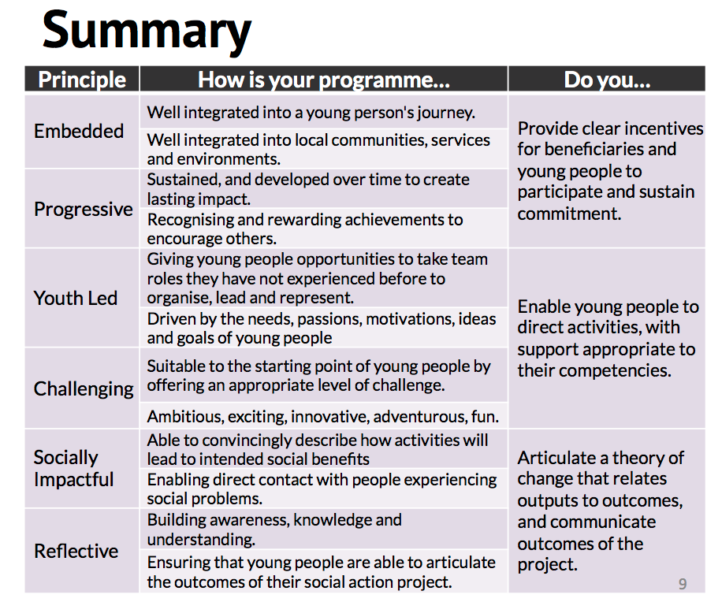

How do your plans reflect the #iwill 6 principles of social action? – 500 words
(principles are here: http://www.iwill.org.uk/about-us/principles/ and see above)

#Embedded
Supertitle Clubs are school hosted, improving accessibility and visibility and teamwork activities are structured in a way that in a way that highlights Positive peer pressure. The clubs are free at point of delivery to students and the resources they create are free to the community (schools cover the costs of the clubs, making it financially sustainable). Being able to co-ordinate, plan, and execute projects that have a positive social outcome is a key trait that improves their ability to get and hold a job.

#Youth-led
The primary starting point for our our project Theory of Change for this project is the needs of the young people with English as an Additional Language and
our staff are recruited specifically for an enabling, facilitating approach that encourages young people. Group decisions are made democratically and consistently by the young people, whose opinions and views are actively south through surveys, focus groups, interviews and research. Much of the group discussion naturally takes place in the home language of the group and because we make sure that no adult present is familiar with that language, the young people are aware of, and empowered by, the trust placed in the group.

# Reflective
The central theme of Supertitle is that their outcomes are ‘real’. Each program that is completely subtitled is released online, forming a concreate achievement that is recognised as such by the group, the school, and the community. These achievements are thus explicitly recognised, celebrated, communicated over social media. The overall outcomes, and the effectiveness of the group and their work is raised as a discussion point regularly by the facilitators who actively guide the conversation.

#Progressive (come back here..
By actively recruiting students within a school for previously undervalued skills we draw in young people who might not have volunteered but who might be at a point of transition. During each session, the group implicitly must break down the narrative structure of an episode, providing many links back into English and Media curriculums, as well as giving valuable experience in media-focused skills for employment.

# Challenging
Individual groups will compete against each other for the ‘prime’ and most prestigious shows to translate – (students start translating children’s programs and work up as they get more skilled). Each session has an clear and challenging target – to complete an episode translation to a high standard –and public reactions to results of previous work is discussed with them.

# Socially Impactful
By the end of the project – clubs should be running living showings – so they can unavoidably see the impact their work has (our previous live showing experience is that there is a high degree of emotion involved). This lets them broadcast their work to the wider community, mix with different generations and by led by them on the best, and worst, parts of the result.

Virgin Money Foundation will make grants of up to £60,000 over two years. Please tell us in more detail what you will spend the grant on. – 500 words
This grant will pay for the introduction of the Supertitle project to the North East and provide the sustained push that is needed to make Supertitle self-sufficient as a project.

Item | Amount | Phase 1 | Phase 2 | Phase 3
Accounting | £850.00 | £- | £- | £850.00
Equipment and other digital costs | £1,800.00 | £1,000.00 | £700.00 | £700.00
Transport | £800.00 | £200.00 | £300.00 | £300.00
Facilitator costs 0.7FT (6 months) | £7,611.45 | £- | £7,611.45 | £-
Facilitator costs 0.3FT (18 months) | £9,786.15 | £3,262.05 | £3,262.05 | £3,262.05
Project manager 0.4FT (24months) | £23,937.60 | £7,979.20 | £7,979.20 | £7,979.20
Publishing , Design, and online content costs | £1,200.00 | £600.00 | £300.00 | £300.00
Insurance, subscriptions and resources such as books | £440.00 | £440.00 | £- | £-
Office costs; phone, internet, printing, sundries, admin services | £900.00 | £300.00 | £300.00 | £300.00
Events: meetings, focus groups, large showings (cinema hire) | £1,400.00 | £- | £400.00 | £1,000.00
Software development | £3,000.00 | £1,500.00 | £1,000.00 | £500.00
Dissemination: conferences attendance, invited talk | £1,700.00 | £- | £700.00 | £1,000.00
Core organisational costs | £5,342.52 | £1,780.84 | £1,780.84 | £1,780.84
Total | £58,767.72 | £17,062.09 | £24,333.54 | £17,122.09

Cost Justification
- Insurance – policy quote from http://insuranceoctopus.co.uk/
- Median Nonprofit Project Manager Salary (United Kingdom) £29,923 http://www.payscale.com/research/UK/Job=Program_Manager,_Non-Profit_Organization/Salary
- Median Training Facilitator Salary (United Kingdom) is £21,747 http://www.payscale.com/research/UK/Job=Training_Facilitator/Salary
- Software engineer – paid by bounty (our code is open, so development can be effectively crowdsourced cheaply if necessary).
- Accountant: quote from accountant
- Equipment cost based on estimation of need – breakdown available.

