Supertitle: Phase two
This is a ‘pretty printing’ of eQuality time’s bid for Virgin’s #iwillTakeAction fund. It also serves as a snapshot of eQuality Time’s position and intention towards the Supertitle Project. It is a living document in its own right and contains a large amount of information and illustration that is intended for sharing with the wider public rather than a funding body.
This document opens with a summary. Questions from the Virgin Application form are highlighted in red.

Supertitle
Supertitle is a school intervention for students with English as an Additional Language (EAL). Students with EAL produce gain confidence, volunteering experience and teamwork skills while producing subtitled versions of UK TV programs by forming ‘translation clubs’ that use specially designed software. This help members of the wider community improve their English and improves the accessibility of UK media and cultural outputs.

Futher reading.
Supertitle is one of eQuality Time’s first projects and we have blogged every stage of it’s development:
2016

- Supertitle Phase 2: report
- Sir Halley Stewart Trust Bid
- Children in Need Funding.
- New shows for Supertitle
- New Shows prepared for Supertitle
- Children in Need interview
- Children in Need Application
- New shows prepared for Supertitle
- The 60 second silent Supertitle video
2015
- Project Update: Supertitle
- London Catalyst
- Funding Success – Awards for all and Supertitle!
- Fail post: Supertitle Funding
- Prototyping Supertitle
- Supertitle, a project for school students with English as an additional language.

Bid

Tell us about your organisation. What does it do? Why was it set up? Who set it up? – 500 words
eQuality Time designs and delivers social interventions, where our end-users work as a group to deliver an end product like a novel or community resource. While focused on their end-goal, our users find themselves improving their skills, and forming effective team bonds. eQuality Time was set up by Dr Joe Reddington in 2014, to address gaps in the education and volunteering sectors.

Two of our projects are:
Supertitle focuses on students with English as an Additional Language. In 2015 it was awarded National Lottery funding to help with the initial pilot project costs. Under the project, students form volunteer groups to translate subtitles for BBC TV programs for relatives and their community. They provide a valuable service while changing their outlook on the value of the own bilingualism and learning valuable IT and team working skills. We’ve run sessions in 10 schools so far, working with around 60 students in six languages.
White Water Writers was initially grant funded from several sources but is now commercially viable. Our facilitators visit schools and lead groups of 10 students through the process of creating a novel. The students start planning their novel on Monday morning and it is uploaded to Amazon on Friday night. The novel writing process is entirely student led - no adult touches a computer key throughout. Over 70 novels have been produced to date and our research with Keele University and Kings College London, shows statistically significant increases in student confidence and locus of control. Students have also demonstrated improvements in their planning skills, use of computers and team work.

Tell us about your project. How will your idea help young people living in the North East to engage in social action? This question will be assessed by our youth advisory panel. – 500 words
# The problem:
BBC iPlayer and other TV on demand services provide subtitling in English. However, almost 1 in ten UK households have a member that doesn’t have English language, (“In 91% of households, everyone speaks English. In 4% no one speaks English as main language.” http://www.theguardian.com/uk/blog/2012/dec/11/census-data-released-live-coverage) with other languages including Polish, Punjabi and Urdu. http://www.independent.co.uk/news/uk/home-news/polish-is-second-most-spoken- language-in-england-as-census-reveals-140000-residents-cannot-speak-english-at-all- 8472447.html In such households UK media is generally not watched in order to avoid (further) isolating members of the household.
Supertitle is an effort to break down such barriers by providing subtitle translations to popular BBC and ITV tv programmes in the common UK second languages of Polish, Punjabi and Urdu.

Supertitle sets up dedicated weekly translation clubs by recruiting volunteer EAL students from schools. They meet once a week to translate subtitles for popular British TV programs. Our software allows groups of EAL students to work together on the translation and to make it available online as a community resource. This facilitates their family members to access popular British programs in their own language whilst also improving the students’ English language skills.

Supertitle will work primarily with secondary school students in the North East who have English as an additional language (EAL). In 2016, in the North East of England, 7.1% of secondary school students in the UK were recorded as EAL students (https://www.statista.com/statistics/331675/england-region-english-additional-language-primary-pupils/), a figure which has almost doubled since 2013 and is likely to continue growing.

# Volunteering goals.
A major reason why young people do not engage in social action is they do not believe they have anything useful to contribute. In particular, EAL students often feel their native language to be of little or no value both in school and peer groups (http://www.ioe.ac.uk/56528.html). Recruiting for volunteers will take place within schools, calling on the EAL students to make use of their second language and unique skill. Once the effects start to extend out into the community, when the local community begin using the Supertitle service to enjoy popular UK TV programs, young people will be even more encouraged to want to take part in the project.

The twin motivations of social advantage and knowing that they have something to contribute mean that young people who may not normally volunteer will be encouraged and likely to want to take part in Supertitle.

Volunteers involved in Supertitle also help to create a social impact within their wider communities. Once translated, the programs are made available to the volunteers’ community, their family and friends, allowing volunteers to feel like a bridge between communities rather than feeling they have to choose a 'side'. The community benefit will be demonstrated as translated subtitles help non-English speakers of households improve their English and thus help integrate them better into society.

Supertitle promotes dual identity amongst young people, allowing them to become more comfortable with their cultural identity and owning their place in modern Britain today. Supertitle supports volunteers’ well-being by helping develop self-confidence in their skills.

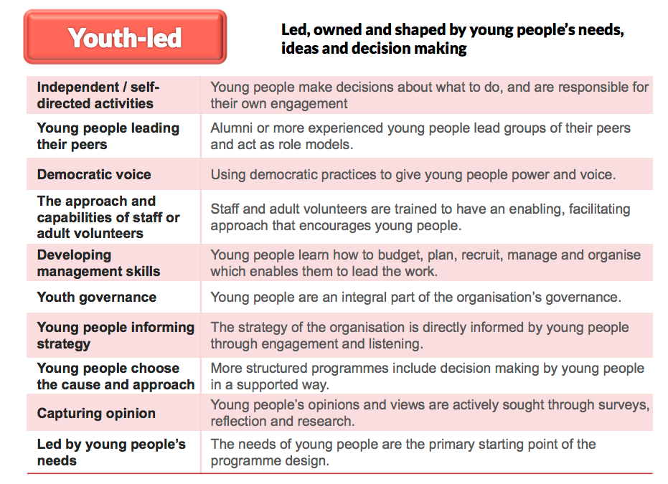

How will you involve young people in the planning and delivery of your project? This question will be assessed by our youth advisory panel. – 500 words (see above)

The primary starting point for our our project Theory of Change for this project is the needs of the young people with English as an Additional Language and
our staff are recruited specifically for an enabling, facilitating approach that encourages young people. Group decisions are made democratically and consistently by the young people, whose opinions and views are actively south through surveys, focus groups, interviews and research. Much of the group discussion naturally takes place in the home language of the group and because we make sure that no adult present is familiar with that language, the young people are aware of, and empowered by, the trust placed in the group.

# Planning
The Supertitle pilot interventions were carried out with four groups of students, all of whom were canvassed for their opinions on the approach. The students specified changes to software (which changed dramatically as a result), delivery type (we created more options for how the intervention could be run), and the delivery of the finished programs (we originally envisaged small groups watching at home- the students we worked with set up larger scale viewings in school halls with presentations).

# Delivery
Each Supertitle club is volunteer led. Volunteers democratically select which TV programmes to translate, the roles that each member of the team will take, and are responsible for making the final decision about when a translation is ready to be put online. Clubs are youth-led to keep the focus on young people and draw upon their creativity, energy and skills to create a positive change in their own communities. This also helps to ensure their commitment to the club as well as to enhance their self-belief, that they can achieve anything they put their mind to.

During the translation process, there is an adult facilitator present for help with the technology aspect but all decisions regarding translation will be made by the volunteers. The only people in the room with knowledge of the target language are the student volunteers, this will help ensure that no other adults will have had an input and the final work is ‘owned’ by the volunteers.

When children choose to write subtitles for UK TV programmes, they are identifying a cultural product that resonates with them. Group discussions of how best to translate a particular phrase explore cultural differences and similarities in a safe, meaningful way.

What evidence do you have to show that your idea will work? How will you measure outcomes? What will happen at the end of the grant? – 500 words
#Evidence
We’ve run sessions in 10 schools so far, working with around 60 students in six languages. Below are a range of testimonials from the student volunteers involved:

“I found this workshop fun and useful because you are helping people that
don’t understand it and need translating it. I am really happy that I was
able to take part in this session and I was able to use my skills to work
as a team”

X

“I found the workshop very useful because I worked well in a team and
it helped me writing with more confidence in Portuguese. Also, I have made
new friends. I have had really good fun”

X

“I found this session very useful because I practised my Portuguese and I
also know that by producing the subtitles I can help Portuguese people in
the UK to understand what they are watching. I found it really fun as well
as useful”

X

“I enjoyed this workshop as my family also face the struggle of not always
understanding shows and I am glad to give back to the community by helping
others who have the same problem.”

X

#How will we measure outcomes?
Outcomes will be measured using a pre-post assessment designed by researchers at Keele University in conjunction with eQualityTime.
The assessment is a questionnaire designed to measure any improvements in children's confidence relating to their cultural identity and feelings of belonging within the local community. All children will be asked to provide their informed consent (along with caregiver consent) before taking part in any assessment.

The social impact within the wider community will be measured using website analytics to keep track of download numbers of the translated subtitles as well as an optional online survey made available when choosing to download the subtitles. Focus groups will also be held using a facilitator who speaks the target language, to measure the social impact felt in the community.

# End of Grant plans…
Supertitle's long-term plan will see the development of a sustainable set of youth-led clubs which will be measured by tool usage as well as recording the figures on club membership.

The data will then be used to write a report to discuss the performance of Supertitle and how the clubs can be improved.

When this grant finishes, Supertitle will be self-sustainable (we have confidence in the willingness of schools for pay for the program) with a small set of youth-led translation clubs in schools across the North East. This grant will allow us to amass a critical body of content and evidence, which we can use to convince schools and colleges to take on the intervention and support facilitator costs. The next step will be to scale the intervention nationally.

How will you use the strength of the Virgin Money brand and the skills of staff from across the business to magnify the impact of your work. How will you help Virgin Money Foundation to raise awareness of the #iwill campaign? - 500 words
The Virgin Money brand will be of enormous help when convincing other schools to introduce the Supertitle project into their schools. The skills made available by the staff from the business will be especially useful in the marketing of the project as well as raising awareness of the importance of social inclusion and the integration of immigrants into UK communities.

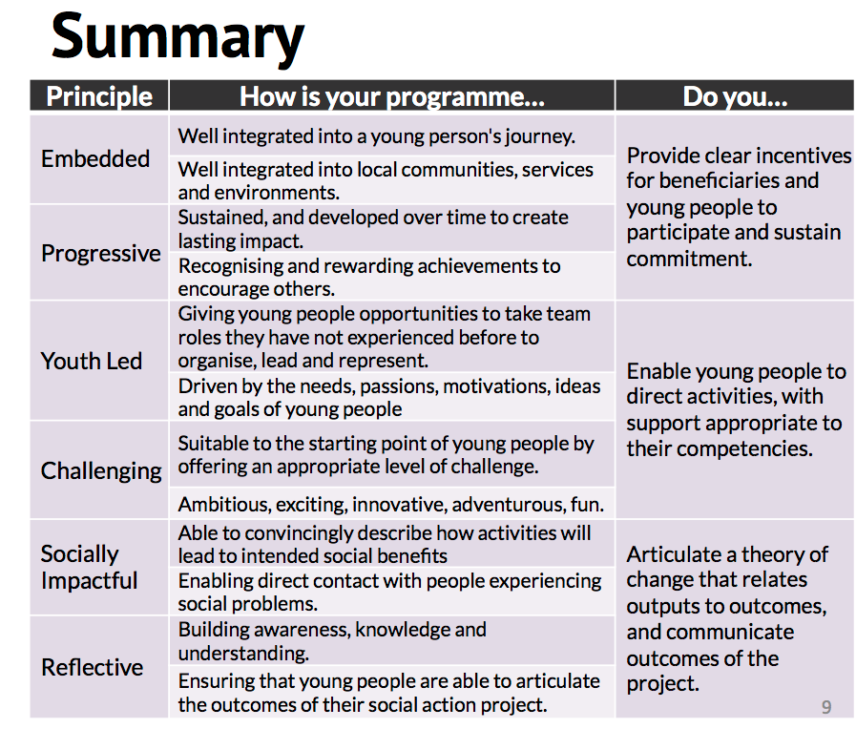

How do your plans reflect the #iwill 6 principles of social action? – 500 words
(principles are here: http://www.iwill.org.uk/about-us/principles/ and see above)

#Embedded
Supertitle Clubs are school hosted, improving accessibility and visibility and teamwork activities are structured in a way that in a way that highlights Positive peer pressure. The clubs are free at point of delivery to students and the resources they create are free to the community (schools cover the costs of the clubs, making it financially sustainable). Being able to co-ordinate, plan, and execute projects that have a positive social outcome is a key trait that improves their ability to get and hold a job.

#Youth-led
The primary starting point for our our project Theory of Change for this project is the needs of the young people with English as an Additional Language and
our staff are recruited specifically for an enabling, facilitating approach that encourages young people. Group decisions are made democratically and consistently by the young people, whose opinions and views are actively south through surveys, focus groups, interviews and research. Much of the group discussion naturally takes place in the home language of the group and because we make sure that no adult present is familiar with that language, the young people are aware of, and empowered by, the trust placed in the group.

# Reflective
The central theme of Supertitle is that their outcomes are ‘real’. Each program that is completely subtitled is released online, forming a concreate achievement that is recognised as such by the group, the school, and the community. These achievements are thus explicitly recognised, celebrated, communicated over social media. The overall outcomes, and the effectiveness of the group and their work is raised as a discussion point regularly by the facilitators who actively guide the conversation.

One of the positive effects of Supertitle is that it helps to increase the cultural confidence of the volunteers. Many of the children we work with have problems fitting in at school or in their local community, often they think that they must choose between either being ‘British’ or being part of their 'home' community. Supertitle helps these children to be a bridge between the two sides, rather than having to choose one.

# Socialy Impactful
By sharing the finished translated TV program with their family and friends, the benefits of Supertitle can be shared in the local community. Watching the subtitled TV show together as a family, including members of the family who may not speak English very well, they can all improve their English in a fun and free way.

Supertitle groups also help to develop knowledge of the English language, something which many EAL students struggle with. Volunteers improve their English language skills in an organic and fun way, as opposed to having to attend special classes during normal school time. However, it is not just English level that improve from participating in Supertitle, it also improves general literacy skills, increases their attention to detail, boosts their ability to work in a team and develops communication skills within the group. Initial testing has demonstrated overwhelmingly positive results with participants and communities. As well as improving attainment, the project engages young people, giving them a voice and channelling it into a tangible achievement they can share with their peers and families

Virgin Money Foundation will make grants of up to £60,000 over two years. Please tell us in more detail what you will spend the grant on. – 500 words
This grant will pay for the introduction of the Supertitle project to the North East and provide the sustained push that is needed to make Supertitle self-sufficient as a project.

Item | Amount | Phase 1 | Phase 2 | Phase 3
Accounting | £850.00 | £- | £- | £850.00
Equipment and other digital costs | £1,800.00 | £1,000.00 | £700.00 | £700.00
Transport | £800.00 | £200.00 | £300.00 | £300.00
Facilitator costs 0.7FT (6 months) | £7,611.45 | £- | £7,611.45 | £-
Facilitator costs 0.3FT (18 months) | £9,786.15 | £3,262.05 | £3,262.05 | £3,262.05
Project manager 0.4FT (24months) | £23,937.60 | £7,979.20 | £7,979.20 | £7,979.20
Publishing , Design, and online content costs | £1,200.00 | £600.00 | £300.00 | £300.00
Insurance, subscriptions and resources such as books | £440.00 | £440.00 | £- | £-
Office costs; phone, internet, printing, sundries, admin services | £900.00 | £300.00 | £300.00 | £300.00
Events: meetings, focus groups, large showings (cinema hire) | £1,400.00 | £- | £400.00 | £1,000.00
Software development | £3,000.00 | £1,500.00 | £1,000.00 | £500.00
Dissemination: conferences attendance, invited talk | £1,700.00 | £- | £700.00 | £1,000.00
Core organisational costs | £5,342.52 | £1,780.84 | £1,780.84 | £1,780.84
Total | £58,767.72 | £17,062.09 | £24,333.54 | £17,122.09

Cost Justification
- Insurance – policy quote from http://insuranceoctopus.co.uk/
- Median Nonprofit Project Manager Salary (United Kingdom) £29,923 http://www.payscale.com/research/UK/Job=Program_Manager,_Non-Profit_Organization/Salary
- Median Training Facilitator Salary (United Kingdom) is £21,747 http://www.payscale.com/research/UK/Job=Training_Facilitator/Salary
- Software engineer – paid by bounty (our code is open, so development can be effectively crowdsourced cheaply if necessary).
- Accountant: quote from accountant
- Equipment cost based on estimation of need – breakdown available.

