Health Innovation Fund
Concept Note

This form should not exceed more than 3 pages in total, and must be in Arial font size 11

Please return your completed form to grants@gsttcharity.org.uk

Part A Summary | Date of application |  | 29/5/2016
A1. Project title in no more than 80 characters: |  | Superhero Cyborgs
Lead applicant |  | Joseph Reddington
Job title |  | CEO
Contact email: |  | joe@equalitytime.co.uk
Applicant organisation: |  | eQuality Time
Department or clinical academic group |  | Prosthetic Physiotherapy
Partner organisations: |  | n/a
Estimated total project cost: |  | £42000
Funding you want from us: |  | £30000
How long the work will take (months) |  | 3
Part B. Fit to Charity Strategic Priorities
B1. Please identify which one of our three priorities that this application is most closely related to:
System Transformation: |  | Cancer: |  | Public Health: | Tick
Part C. Assessment criteria
Please tell us how your project and innovation demonstrates the following:
C1. Significant potential benefit
C1.1 Please describe the issue you wish to tackle. Briefly state why it is an issue, especially as it affects Lambeth and Southwark and/or Guy’s and St Thomas’ NHS Foundation Trust (GSTFT).
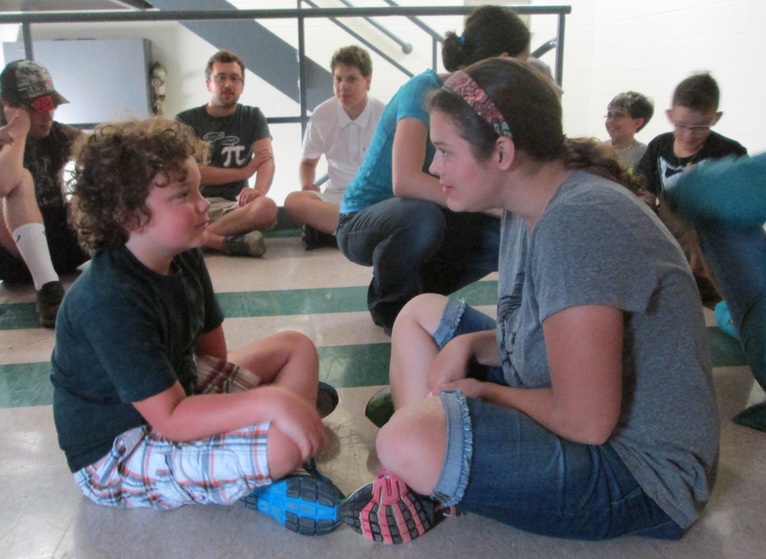
Every year around 20 under-16 year olds lose part of an arm (Mostly because of trauma) (http://goo.gl/4nSmVo) with many in London, including GSTFT. Such children are given pale and functional prosthetics that they can reject or be embarrassed by.
There are so many types of upper limb issues that getting help can be hard. Many professionals in health care do not see enough cases to build up expertise. (http://goo.gl/0ovNA7) and this is even more true of people with the 'making' experience to help customise a new limb.
A child who has acquired limb difference through amputation is more likely to feel a serious and very personal sense of loss. The child must adjust to a different way of living. This takes emotional and physical adjustments. (http://goo.gl/aOCPzQ) There are few chances for children with limb differences to meet each other, and share their stories.

There may be times when a parent thinks the child should be using a prosthesis, but the child doesn’t want to. When it comes to prosthesis use, children, parents and healthcare teams may sometimes see things quite differently.( http://goo.gl/h7sJrK)
Our project will enable children to work together with volunteer designers and engineers to create customized, personal prosthetics while also meeting other children and getting the chance to hear the stories of others
C1.2 Please describe the new service or practice you wish to introduce and demonstrate how this relates to or is distinct from current or previous attempts to address the issue in hand.
We’d like to bring the Californian 'Superhero Cyborgs' model to the UK. In this model the children work with designers and engineers to design and prototype their own body modifications. This takes place in group workshops that also allow children to share both their designs and their stories as well as though a network of volunteers. GSTFT's location makes it the perfect place to work with the large nearby communities of makers and designers.
The contact with networks of volunteers and makers scaffolds the child's acceptance of their body modification as an extension of both their body and their identify. Simultaneously, the collaborative (and sometimes competitive!) process of design with peers allows peer-support and discussion around the nature and effects of limb difference.
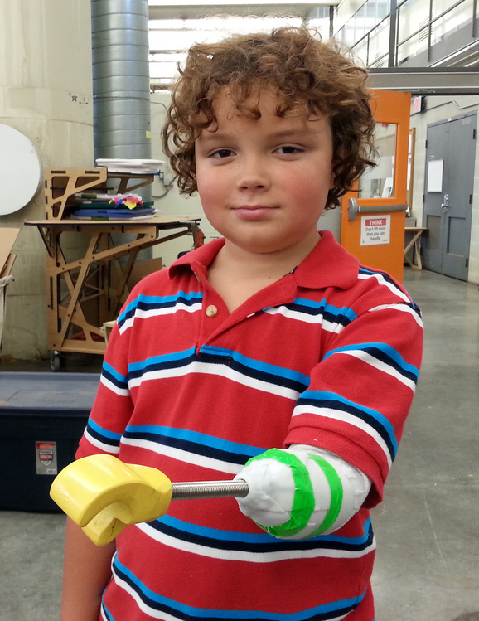
The ‘change making’ part of this project is in three phases:

Phase 1: Stakeholder engagement
Project stakeholders include:
- users and their families,
- limb difference charities such as Reach,
- physiotherapists (public and private)
- Maker communities and design communities

A major focus of the stakeholder engagement is London ‘Maker’ community, who have the equipment and skills to truly make a difference in the limb difference community. Engagement methods include invited talks, targeted advertising, and referral from known actors in the area.

Phase 2: Superhero Cyborgs workshop launch
Our second phase is to bring trainers from KidMob (the designers of the Superhero Cyborg project) from San Francisco to run a launch workshop. In the launch workshop a group of children are taken through the design and prototyping process.
One of the primary aims of the workshop is to train suitable volunteers in the UK in the best way to work with children with limb differences in a design context.

Phase 3: Volunteer co-ordination and consolidation
The third phase of volunteer co-ordination and consolidation is designed to establish a network of trained volunteers in such a way that GSTFT can make new referrals aware of the potential of engaging with design and put them in touch with the volunteer co-ordinator.

The co-ordinator will put them in touch with a trained designer who will be able to start taking them though a process – either individually or as part of a group.
C1.3 Please describe the anticipated improvements in people’s health or in the quality or efficiency (or both) of the health and care system.
The volunteer and expertise sharing network that is created by the Superhero Cyborg project will:

Help children with recent amputations feel more comfortable about their body modifications
There is a clear and present need for children who have limb difference as a result of surgical procedure to adapt to new physical and emotional realities. By involving children in the design of what will be a uniquely identifying part of their appearance we allow children to build up confidence and acceptance of the use of body modifications.
Provide stronger links between users, technical volunteers, and the public sector
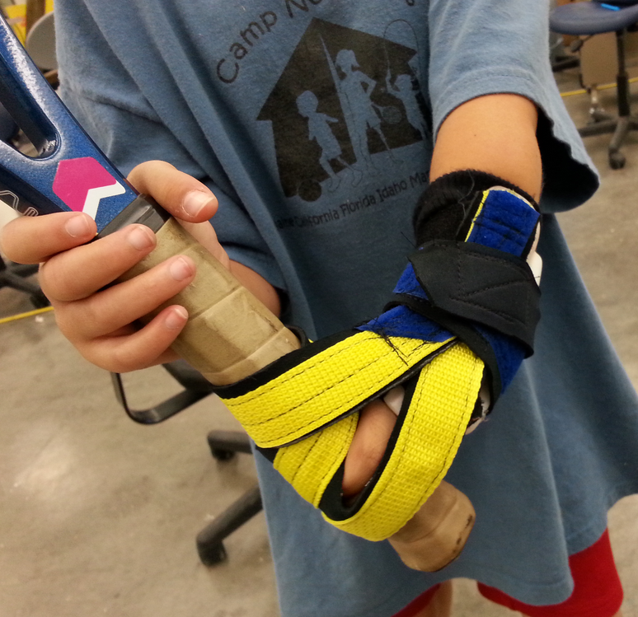
There are large communities of designers and engineers in London that have outstanding levels of technical qualification and are involved with the ‘maker’ community as a hobby. This level of technical skill is one that the NHS is sorely lacking and increasing the amount of collaboration between these volunteers and service providers can only provide an a platform for future innovation.

Give families the service that they deserve
The resulting network will mean that users and their families who might have been frustrated with the service that the NHS provides, are instead show the ability of NHS services to co-ordinate with outside interests and services to provide innovative solutions.

C2. Overcoming the barriers to adoption.
C2.1 Please identify who will make the decision whether to adopt your innovation in Lambeth and Southwark and/or GSTFT. Describe what you have done so far to consult these decision makers.

Although the project has the potential for a large amount of effective change, it’s nature as a co-ordination of volunteers and service users means that very little NHS resource is used. For example, once set up, we expect the endeavour to be self-funding. As a result, we require only co-operation of the lead for Prosthetics at GSTFT, Nancy Pretty, with whom we have set up a meeting.
C2.2 Please provide a summary of the evidence required by the decision makers, and describe what further work will be undertaken to gain their support.
We think that this innovative project can scale dramatically in other cities in the UK and as such intend to collect a wide range of data to prove it’s effectiveness in both GSTFT and other contexts.
We have strong links with a range of researchers throughout the UK - the main project contact is a former academic and we have researchers at the university of Keele who have designed our data collection tools, and who will analyze and publish the information.
We shall collect qualitive data in the form of interviews with other stakeholders and focus groups with parents and children (separately). Six month follow up interviews with children who have designed their own limbs will be included. We shall also collect a range of ‘passive’ quantitative information in terms of volunteers, training sessions, number of referrals, number of referrals that resulted in a completed design and a number of other factors.

C3. High-quality team
C3.1 Describe the project team
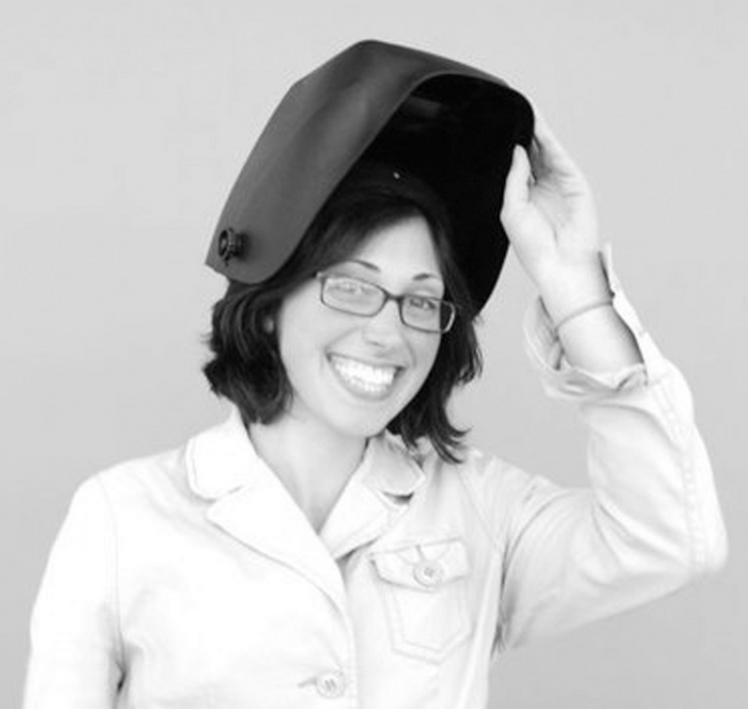
The project will be lead by Dr Joseph Reddington, CEO of eQuality Time. Dr Reddington has lead many design and technology interventions, including the successful educational intervention http://whitewaterwriters.com/ (funders: Ernest Cook and SHINE). Dr Reddington also co-ordinates the Open Source assistive technology project AzuleJoe (http://www.nesta.org.uk/news/2016-inclusive-technology-prize-winner-set-give-more-people-voice) and is a member of the team for the open licensed pageset Communikate.

Training and advice on this project will be provided by Kate Ganim (right), who originated the Superhero Cyborg project in San Francisco. Kate co-founded KIDmob, a mobile, kid-integrated design firm that believes design education is an opportunity for creative engagement and community empowerment. Our “mob” of professional designers and engineers helps kids and communities solve real, local challenges.
The team will be advised by Kate McCallum, an assistive technologist and member of eQuality Time, and administration support will be provided by Anastasia Driga.

